Creating an IAM Role for SSM Connectivity

Procedure:
- Navigate to the AWS IAM console and select Create role.
- Under Trusted entity type, choose AWS Service.
- For the Use case, select EC2, then click Next.
- On the Permissions page, search for and attach the policy AmazonSSMManagedInstanceCore
- Click Next to proceed.
- Provide a role name — for example: aws-ec2-ssm-connect.
- (Optional) Add any necessary tags for resource organization or identification.
- Select Create role to finalize the setup.

Launching an Ubuntu EC2 Instance for NGINX Deployment

Procedure:
- Navigate to the AWS EC2 console and select Launch Instance.
- Enter an instance name, for example:
ostad-batch-08-or-ubuntu-nginx-ec2-01
(Ensure it follows your organization's naming convention.)
- Select Ubuntu as the operating system.
- Choose the latest Ubuntu Amazon Machine Image (AMI).
- For Instance-type, select “t3.medium” (recommended to use the latest generation instance types).
- Create a new key pair or use an existing one—this will be required for server access.
- Expand Network settings and configure the following:
  - Select the appropriate VPC.
  - Choose a subnet within your private network.
  - Disable Auto-assign public IP.
  - Select an existing Security Group, or create a new one with:
    - SSH (port 22) restricted to your IP.
    - HTTP (port 80) open to the internet.
    - HTTPS (port 443) open to the internet.
- Under Storage, choose the gp3 volume type.
- In the IAM instance profile section, select the IAM role created earlier (aws-ec2-ssm-connect).
- Review all settings and click Launch Instance.

Because the server is deployed in a private subnet—and there is no VPN or bastion host available—we will establish access using AWS Systems Manager (SSM).

We can initiate the connection using a command similar to the following:

aws ssm start-session –target <instance-id> --profile <your-aws-profile>
aws ssm start-session --target i-0b5b9b0b4c6a055e9 --profile sarowar-ostad

Configuring the Server and Deploying NGINX

- Obtain Elevated Privileges
Begin by switching to a privileged shell for administrative tasks:
sudo -i
- Update the Server Packages
Ensure the system is fully up to date by running:
apt update && apt upgrade -y
- Install NGINX
Install the NGINX web server package:
sudo apt install nginx -y
- Start and Enable NGINX Service
Start the service and ensure it automatically runs at boot:
sudo systemctl start nginx
sudo systemctl enable nginx
sudo systemctl status nginx

The NGINX status output should show active (running)

Setting Up a Classic Load Balancer

Since the EC2 instance resides in a private subnet, direct access over the internet is not possible. To provide external access to NGINX, we will configure an AWS Classic Load Balancer.

- Navigate to the AWS EC2 Console.
- On the left-hand menu under Load Balancing, select Load Balancers.
- Click Create Load Balancer.
- Choose Classic Load Balancer (previous generation).
- Specify a load balancer name, for example:
nginx-load-balancer-classic-01
(Follow your organization’s naming convention.)
- Configuration Settings:
  - Scheme: Internet-facing
  - VPC: Select the same VPC where your Ubuntu EC2 instance resides
  - Subnets: Select a public subnet in the same Availability Zone as your EC2 instance
  - Security Group: Choose an existing one or create a new security group with:
    - Port 80 (HTTP) open to the internet
    - Port 443 (HTTPS) open to the internet
- Health Check Settings:
  - Ping path: /
  - Uncheck Enable cross-zone load balancing
  - Leave other settings at their default values
- Create the load balancer and note the DNS name assigned to it.

Registering the EC2 Instance with the Load Balancer

- After the load balancer is created, navigate to the Target Instances tab.
- Click Manage Instances.
- Select your Ubuntu EC2 instance.
- Click Save Changes.

You should now see the instance health status as: In Service

Now you can browse
http://your-classic-loadblancer-dns-name.
http://nginx-load-balancer-classic-01-1020113364.us-west-2.elb.amazonaws.com/

you can use this index.html https://github.com/md-sarowar-alam/module-03/blob/main/index.html

Now we will create new Nginx server block

First, create a dedicated directory under /var/www/ named after your server—for example, “batch08.ostaddevops.click”. Inside this directory, create an html subdirectory where the index.html file will be stored.
Use the following commands to create the required directory structure and prepare the server block configuration files.

Registering a Domain and Configuring Route 53

To proceed, we will register a domain, create the corresponding hosted zone, and configure the necessary Route 53 DNS records.
For cost efficiency, we selected a “.click” top-level domain, as it is among the lowest-priced options available in AWS. Complete the required contact information during the domain registration process and submit the form. A verification email will be sent to the associated email address; once you verify the request, the domain will be successfully registered, and AWS will automatically create the corresponding Route 53 Hosted Zone.
You can then proceed with creating and managing the required DNS entries within that hosted zone.
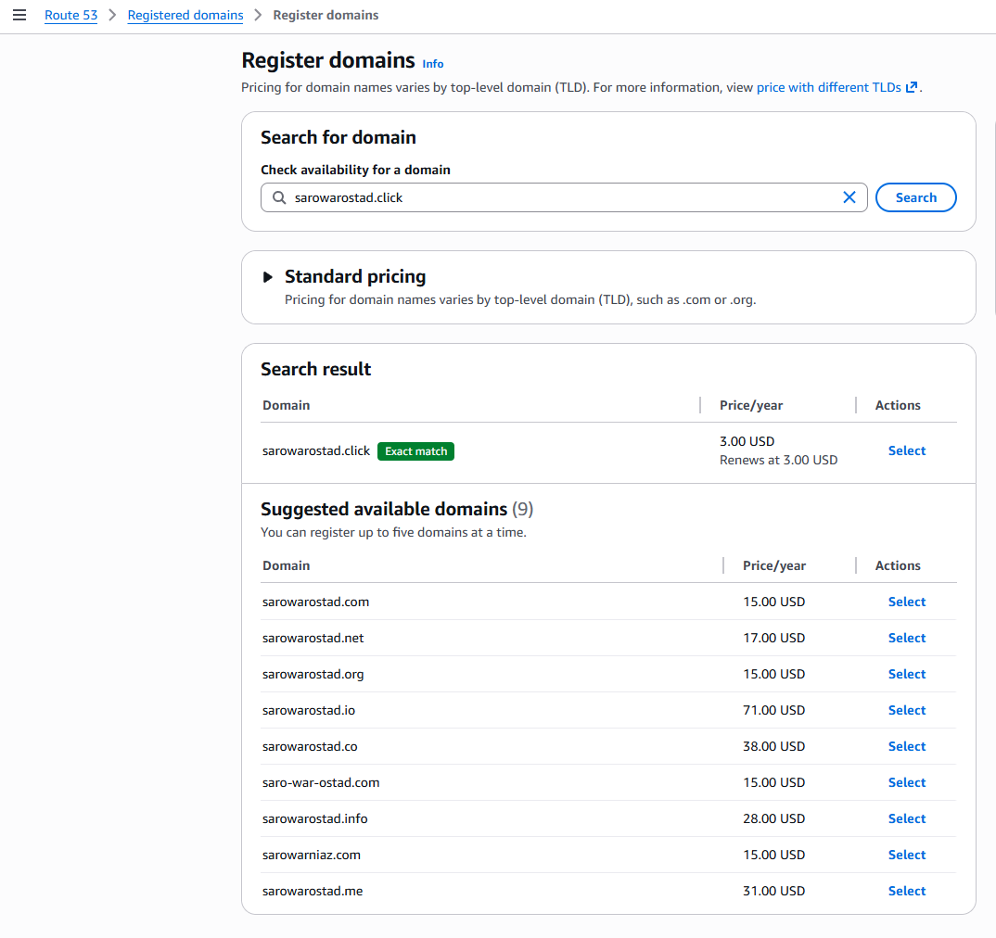

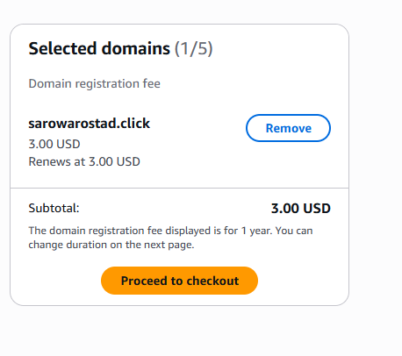

Install Certbot + Route53 plugin + nginx plugin
sudo apt update
sudo apt install -y certbot python3-certbot-dns-route53 python3-certbot-nginx

Dry run
sudo certbot certonly \
--dns-route53 \
-d ostaddevops.click -d '*.ostaddevops.click' \
--preferred-challenges dns \
--dry-run

Issue the real wildcard certificate
sudo certbot certonly \
--dns-route53 \
-d ostaddevops.click -d '*.ostaddevops.click' \
--preferred-challenges dns \
--agree-tos --no-eff-email --email sarowar@hotmail.com

Certs are written to:
/etc/letsencrypt/live/ostaddevops.click/fullchain.pem
/etc/letsencrypt/live/ostaddevops.click/privkey.pem

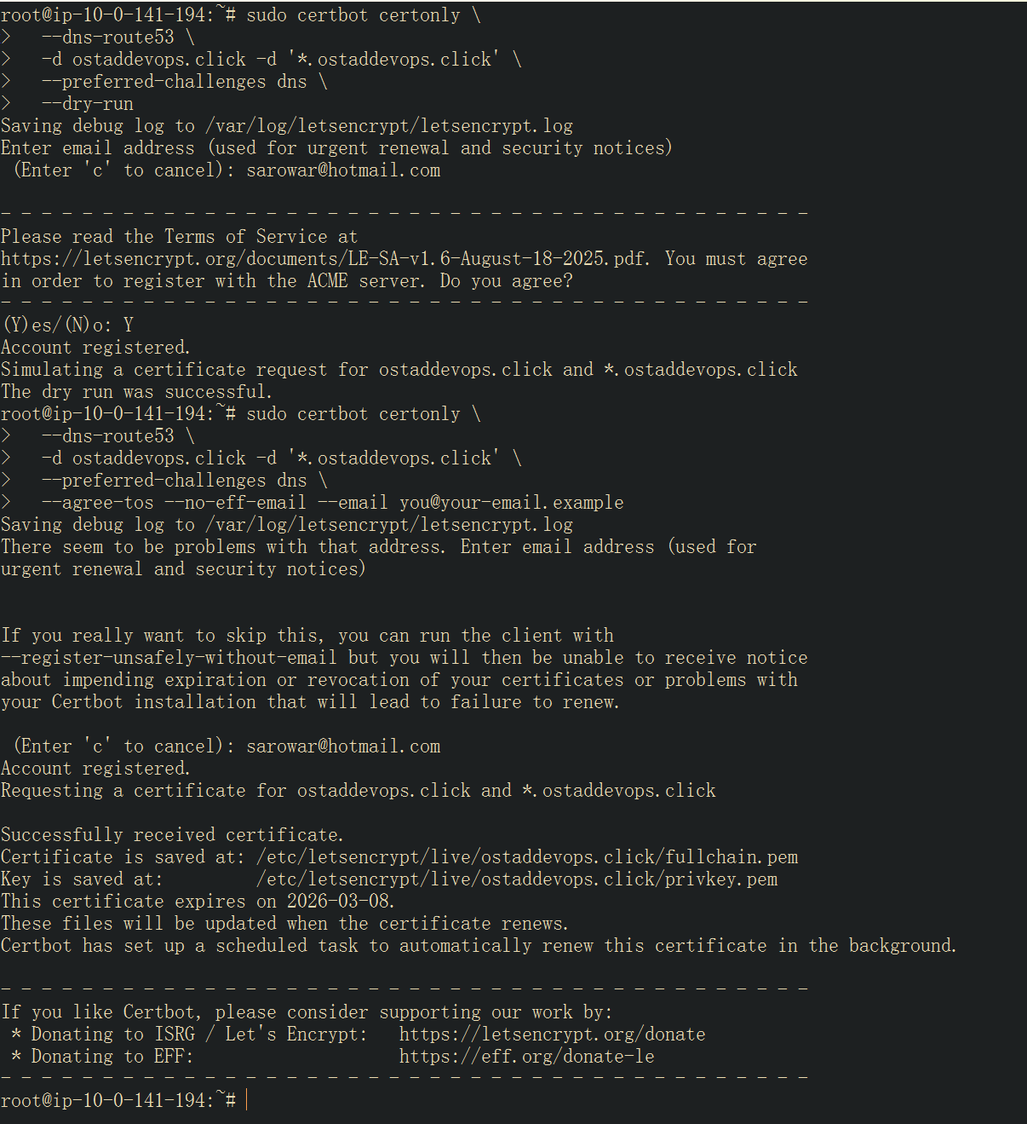

Configure nginx server block to redirect port 80 to 443 ~!

Cron Jobs:

